Please note the new date for this event

Coleman Street Ward Club

Founded 1862

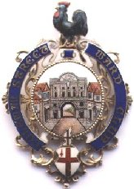
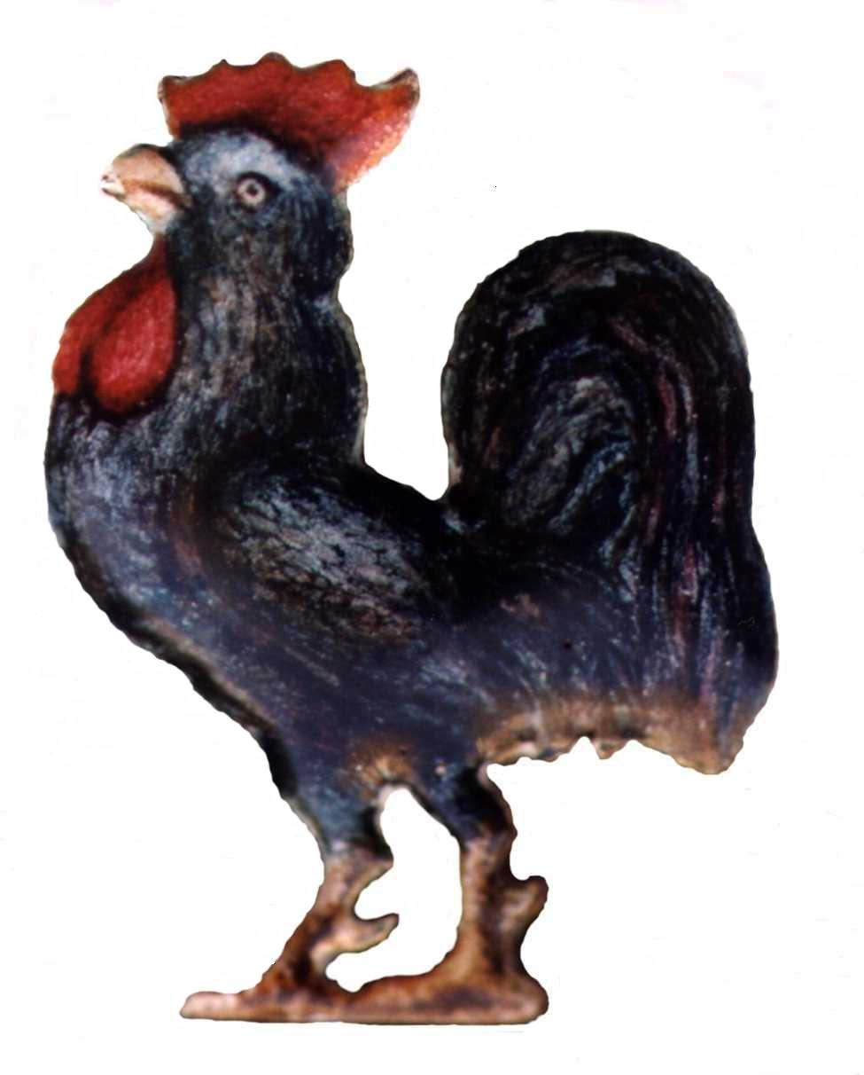

President: Alderman Sir Peter Estlin

Chairman: David Mortlock

Visit to the Old Royal Naval College Greenwich and Meal Afterwards

Tuesday 24th January 2023. Meet at the entrance located in

King William Walk, London SE10 9NN at 3.15pm.

Our Chairman, David Mortlock, has arranged a visit and guided tour of the Old Royal Naval College in Greenwich, a World Heritage Site that has the stunning Painted Hall. Following the visit we will be dining afterwards at about 6pm in the Nile restaurant at the Quintessential Trafalgar Tavern that has stunning riverside views. If you can’t make the visit then you are welcome to join us for dinner instead.

The guided tour and entrance fee will cost £20 and this will allow you to visit the Old Royal Naval College over the following year. We will be on the ‘Combo Tour’ and that will cover a tour of the whole site and include the Painted Hall.

After our hour and a half visit we will walk the short distance to the Trafalgar Tavern, Park Row, Greenwich SE10 9NW. This Grade 1 listed building dates from 1837 and serves good quality British dishes in its beautiful riverside restaurant. It has an interesting history and was a venue where William Gladstone and Charles Dickens could be seen dining next to each other.

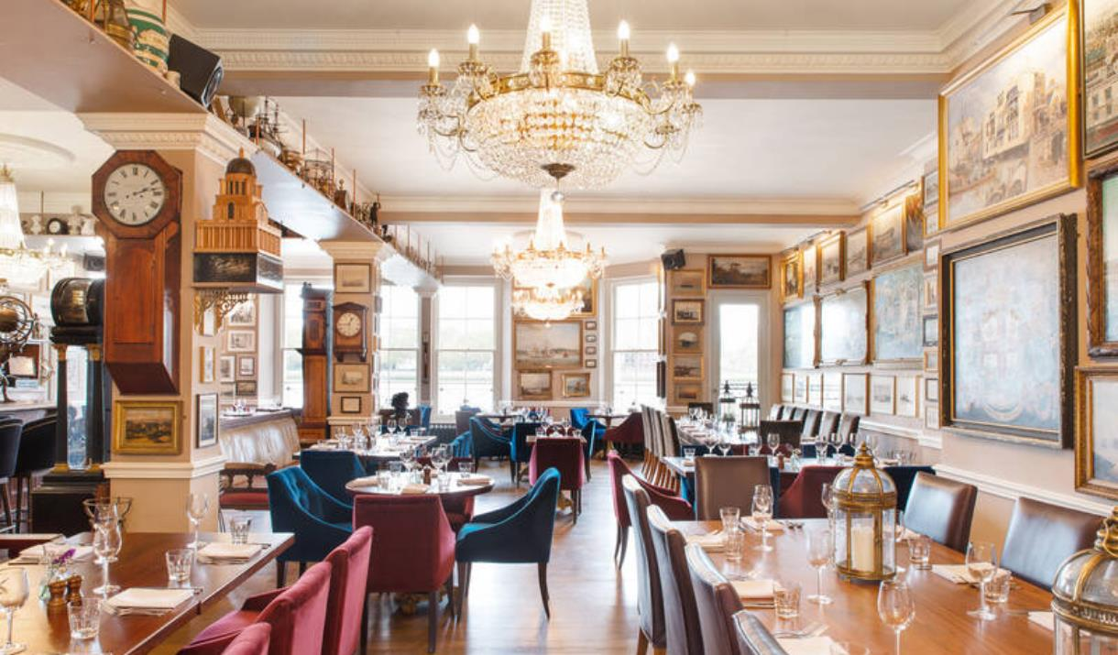

Typically a two course meal will cost about £30 per person and any drinks you have will be extra on-top. In order to gauge the number of places to reserve we are asking members to return their booking forms by 21st December 2022.

Eric Stuart-Bamford
Acting Hon Sec CSWC.

Please return (preferably by email) to secretary@colemanstreet.org
By Post to: Secretary CSWC, 6 Langdale Close, Woking, GU21 4RS.

Visit to the Old Royal Naval College (ORNC) Greenwich and Meal Afterwards
Closing date: 21st December 2022

Visit to the ORNC - Please reserve ……… places (at £20 pp)……………….

Meal at the Trafalgar Tavern – Please reserve …..places (£5 deposit pp)……….

I have paid by BACS to the Coleman Street Ward Club account 20-32-00; 50427721, using the reference NC22 Your Initials & Surname.

I have enclosed my cheque for £………………. payable to ‘Coleman Street Ward Club’

Title & Name:……………………………………………………………………….

Title & Name(s) of Guest(s)……………………………………………….…………..

Member’s Address:……………………………………………………………………

Mobile number::……………………………………………………..……………

Email :………………………………………………………………………………

