Coleman Street Ward Club 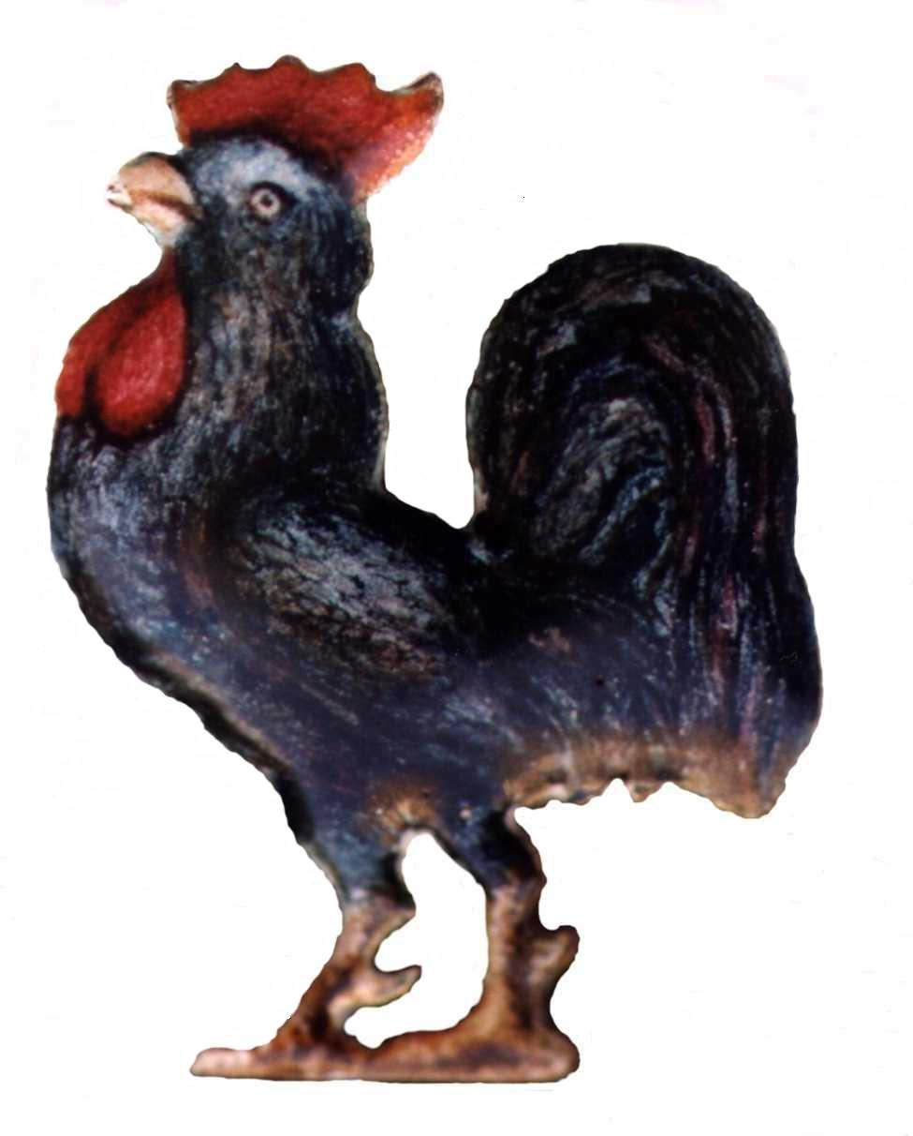

Founded 1862
President: Alderman, Sir Peter Estlin
Chairman: Mr David Mortlock

Notice of the Annual General Meeting of Colman Street Ward Club, 2023
The AGM 2023 is to be held at the RAF Club, 128 Piccadilly, London, W1J 7PY,
at 6.15pm on Thursday 9th March 2023.
It is intended to dine (Hot Fork Buffet) at the RAF Cub after the AGM. The booking form for dining, menu and cost attached to the agenda. Please be aware a security check of attendee’s names will be in place on entry of the RAF Club.
Dress Code; Suit or jacket, smart trousers, collared shirt, tie & appropriate footwear

AGENDA

- Introduction and Welcome

- Apologies

- The Minutes of the 2022 AGM

- Chairman’s Report

- Hon Secretary’s Report

- Hon Membership Secretary’s Report

- Hon Treasurer’s Report

- Webmaster’s Report

- Resolution to Agree change in Rules to allow Joint Hon-Secretaries

- Appointment of Officers and Committee

- Programme of events for 2023-24

- Honoraria

- Charitable donations

- AOB

- AGM 2024, March 2024 tbc

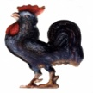
Booking Form, Coleman Street Ward Club AGM 2023
RAF Club, 128 Piccadilly, London, W1J 7PY, 6.15pm Thursday 9th March 2023

I will be attending the AGM and dining:___________

I will attending the AGM and NOT dining:____________

Please return this slip, preferably by Email, or to the postal address below:
E. Stuart-Bamford, 6 Langdale Close, Woking, GU21 4RS.

Please reserve ……………place(s) for the FORK BUFFET at £42 pp. Drinks not included

Enclosed my cheque for £………………. payable to Coleman Street Ward Club or paid by BACS to the Coleman Street Ward Club account 20-32-00; 50427721, using the reference AGM23 and your name. Please email a copy of this form to the Secretary.

Members
Name:……………………………............ …………………………

Member’s Address ………………………………………………….

Phone Number:……………………Email :……………… ……….
Dietary Requirements:…………………………………………………………

Hot Buffet Menu:
Chicken Chasseur with Rice.
Vegetarian Lasagne
Selection of Vegetables
Mixed Berry Cheesecake with Cream
Coffee & Mints

