Coleman Street Ward Club

Founded 1862

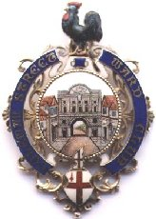
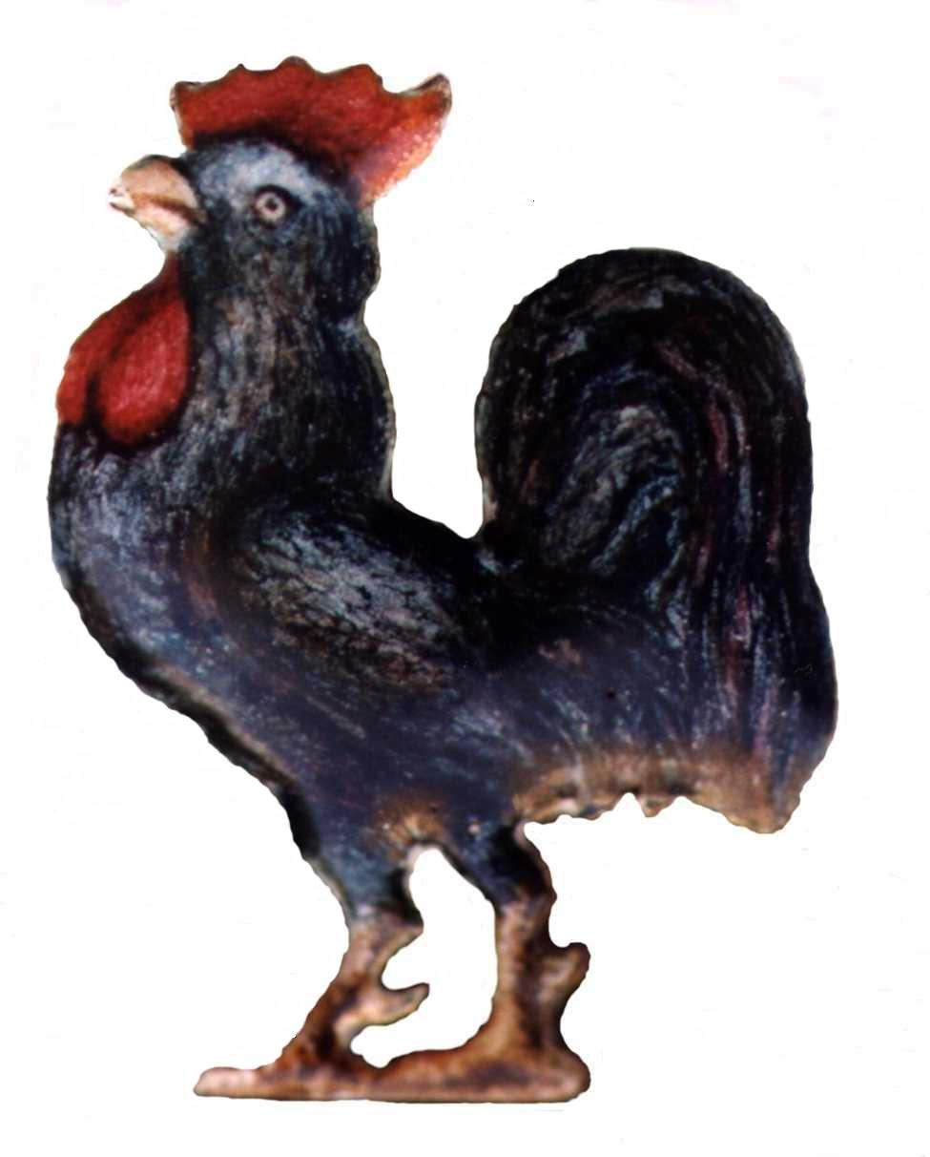

President: Alderman Sir Peter Estlin

Chairman: David Mortlock

Visit to the Mithraeum Space, guided tour of the Walbrook area and Afternoon Tea at the Walbrook Club

Thursday 9th February 2023. Meet at the entrance to the Mithraeum Space located in

12 Walbrook London EC4N 8AA at 12.30pm.

Our Chairman, David Mortlock, has arranged a visit to the London Mithraeum Bloomberg Space where the Roman Temple of Mithras has been returned to the location of its discovery in the heart of the City. Situated on the site of Bloomberg’s European headquarters in Walbrook, the reconstructed temple showcases a selection of the remarkable Roman artefacts found during excavations. The space also hosts a series of contemporary art commissions.

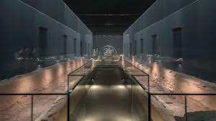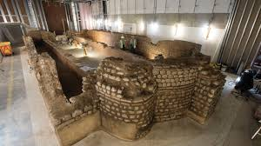

Our visit will be an immersive experience that will bring the bustling world of Roman Londinium to life by unlocking the stories behind the city’s first Londoners. This will be followed by an easy-walking guided tour on which you will learn more about the history of the Walbrook area.

From 2pm to 4pm we will have the unique experience of having afternoon tea in the dining room of the exclusive Walbrook Club, the only family-run private members’ club in the City of London. The Walbrook is, above all else, discreet, elegant and welcoming, and underpinned by attentive service with high standards of fine dining.
The dress code for gentlemen is a jacket or blazer, tailored trousers or smart chinos and collared shirts and for ladies business attire is required.

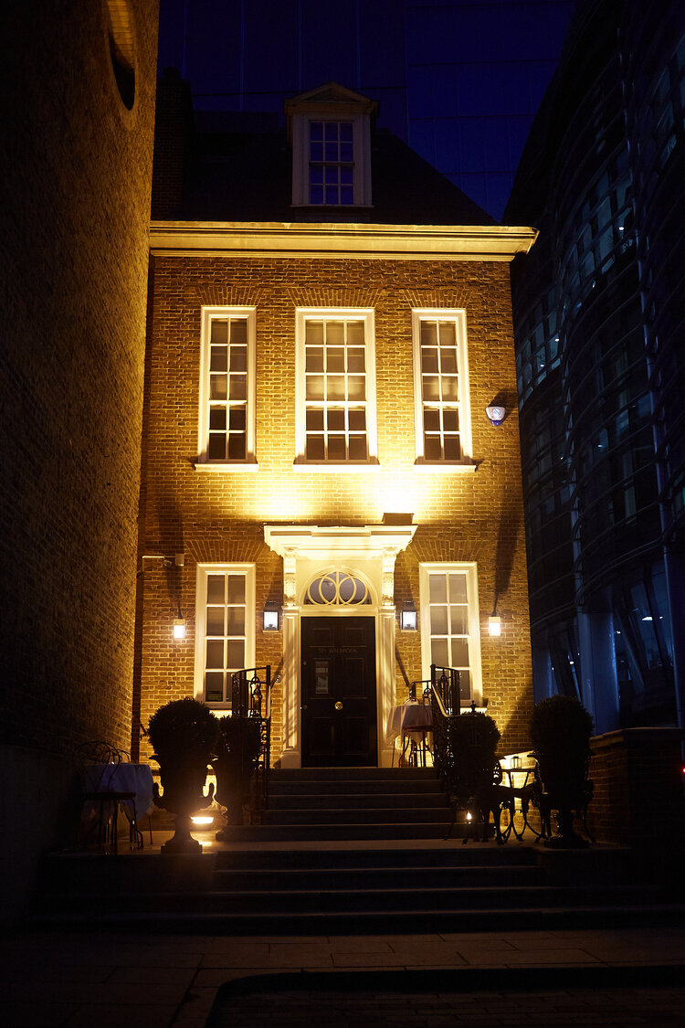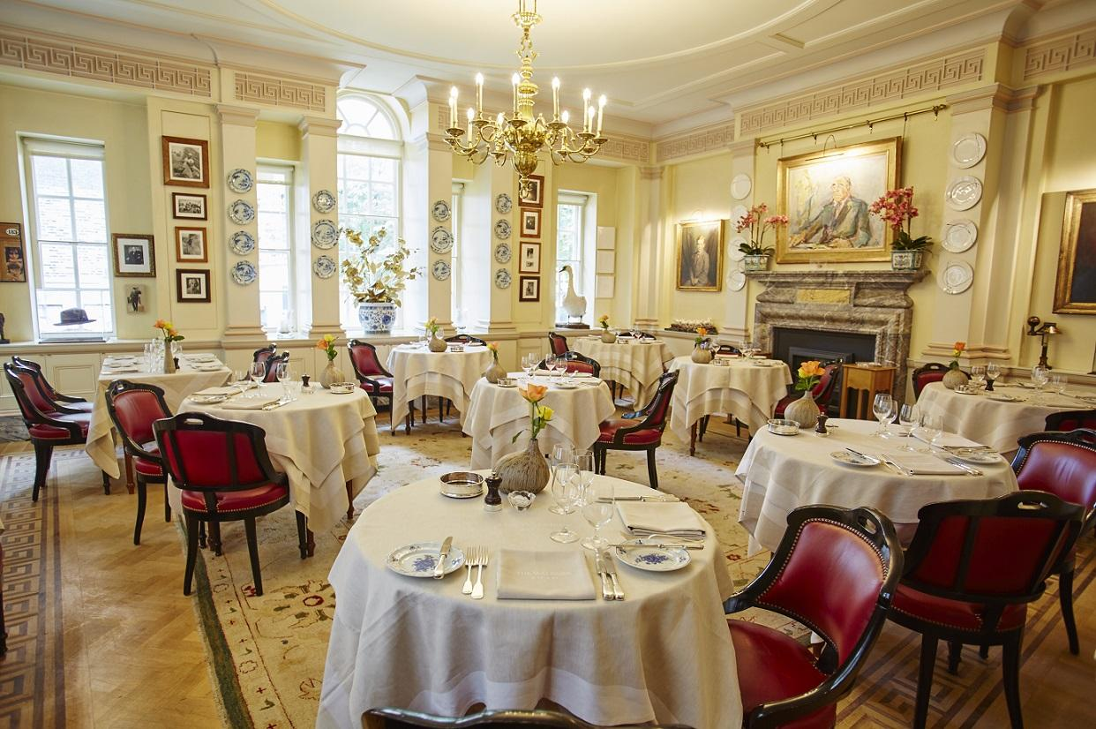

As this will be the last event of his year of office, before the AGM on 9th March, our Chairman would especially like to see as many members and their guests as possible.

Eric Stuart-Bamford
Acting Hon Sec CSWC.

Please return (preferably by email) to secretary@colemanstreet.org
By Post to: Secretary CSWC, 6 Langdale Close, Woking, GU21 4RS.

Visit to the Mithraeum Space and afternoon tea at the exclusive Walbrook Club
Closing date: 9th January 2023

Please reserve …two (2) places (at £56 pp)……£112……….

I have paid by BACS to the Coleman Street Ward Club account 20-32-00; 50427721, using the reference WC23 Your Initials & Surname.

Title & Name:…Mr Paul Ramsay……………………………………………….

Title & Name(s) of Guest(s)…Mrs Lindsey Ramsay………………….…………..

Member’s Address:……Little Maples, Church Road, Cholsey, OX10

Mobile number::………07517563935………………………………..……………

Email :…………………ramsey7115@aol.com……………………………………………

